**Elexoft Technologies (https://www.elexoft.com/):**

Working from 2015

**Headquartered:** Hasan Abdal, Pakistan

Projects completed 200

**Technologies:** C#, ASP.Net, iOS, php, html5, CSS3, javascript, nodejs, mysql, Laravel, Vue, wordpress, bootstrap.

**Services:** Web development, graphic designing, digital marketing, mobile apps, CRM software, SEO, iOS, ASO, Business Intelligence

**Portfolio:** Restaurant food ordering app, Banking and chat app, 6ix Taxi mobile app, Yiflo table reservation Ipad app, News app, InGraphs, Simis Collection, emergence team website etc

Here we can show the year when we started and the number of projects we have completed and happy clients.



This is the slider; we can show that in which technologies we are working on. When you put cursor on these technologies then side arrows will appear.

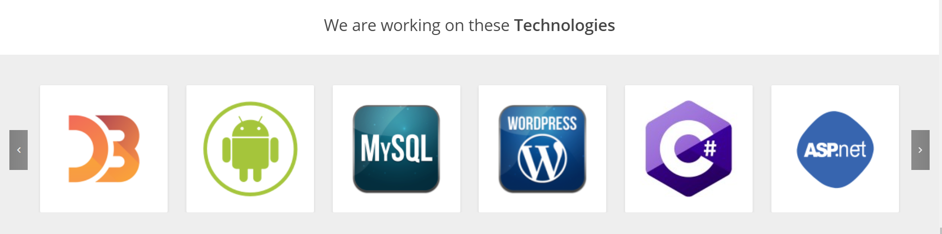

If you want to add clients, here is the button/slide bar we can go forward and backward

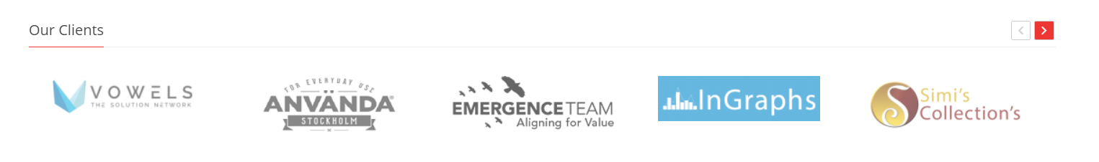

**IntellectSoft (https://www.intellectsoft.net/):**

Since 2007

**Headquartered:** USA

**Services:** Enterprise Software Development, Mobile App Development, QA & Testing, UX/UI design, IT consulting, cyber security, web development, app developers etc

**Technologies:** Cloud computing, Blockchain Development, UX/UI design, Internet of things

**Platforms:** iOS, windows, android, hybrid platform, Azure

**Offices:** USA Miami, Ukarine KYIV, UK London, Norway Oslo, USA New York.

**ScienceSoft Professional Software Development(https://www.scnsoft.com/):**

Since 1989

**Headquartered:** McKinney, Texas

**Services:** Software Development, Application Services, QA & Testing, UX/UI design, IT consulting, cyber security, Data Analytics etc

**Technologies:** .Net, java, python, php, html5, CSS3, javascript, angular, react.js, nodejs, Vue.js, iOS, android, ionic, mysql, oracle etc.

**Platforms:** Microsoft Dynamics 365, SharePoint and Office 365, Microsoft Power Bi, Microsoft Azure, Magneto, Amazon web services etc

**Offices:** USA, Finland, Latvia, UAE

**Arbisoft(https://arbisoft.com/):**

**Services:** EnterpriseSoftware Development, Mobile App development, web app development, DevOps, web scraping & data services

**Technologies:** java, python, Django, angular, react.js, mysql etc.

**Offices**: Lahore, USA, Kuala Lumpur

**10Pearls (https://10pearls.com/):**

Since 2004

**Services:** Software Development, Mobile App development, web app development, data analytics, UX/UI design, QA & testing, DevOps etc

**Technology platforms:** AWS partner network, google cloud, salesforce, SAP Ariba, Azure etc

**Offices**: DC, New York, Toronto, London, Dubai, Karachi, and Medellin.

**ClearSummit:**

Since 2014

**Headquartered:** USA

**Services:** Mobile App development, web app development, UX/UI design etc.

**Technologies:** python, Django, react.js, react native, iOS, android, AWS etc.

**Offices:** Virginia and Los Angeles

**Itransition(https://www.itransition.com/):**

Since 1998

**Services:** Application development, Application Security, Enterprise app integration, QA & Testing etc.

**Technology Advisor:** Salesforce, Cloud, Blockchain, Cyber Security etc.

**Offices:** USA, UK, EU

It’s a mouse hover so, when you put cursor on any of these text then you get complete info.

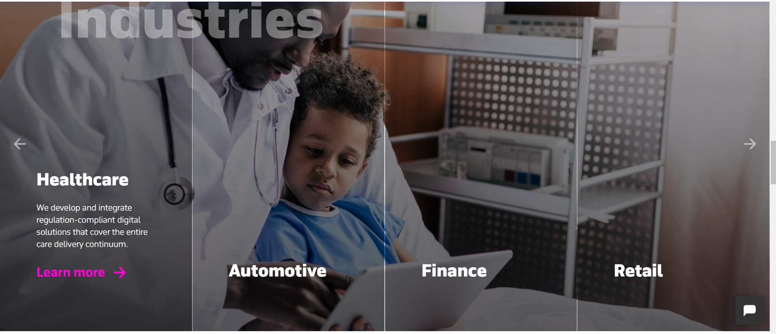

**SideBench:**

Since 2012

**Headquartered:** Los Angeles

**Services:** Mobile App development, web app development, UX/UI design, app testing etc.

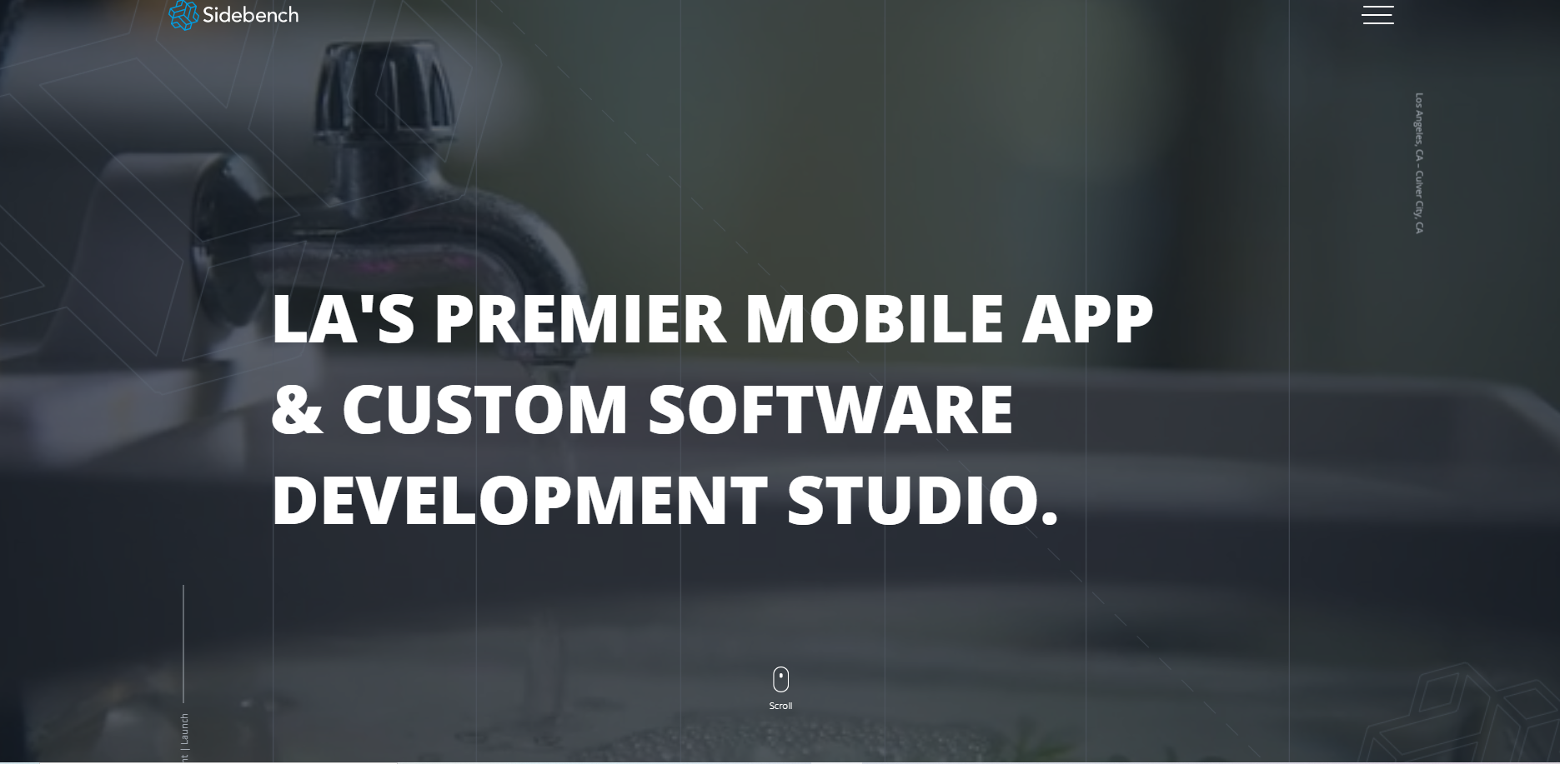

**SimForm:**

Since 2010

**Services:** AI/ML development, Software testing, web app development, Software Product etc.

**Technologies:** Angular, reactjs, nodejs, react native, python, mobile app, php, flutter etc.

**Offices:** Austin, San Diego, Los Angeles, Chicago, San Francisco, Canada, Orlando, Boston, Houston, and Dallas

**NetSol:**

Since 1997

**Services**: Software Project Management, Data Management, and Data Analysis

**Offices:** Lahore, Calabasas, London, Beijing, Sydney, Bangkok, Shanghai

The thing in the background which are blue lines it looks interesting

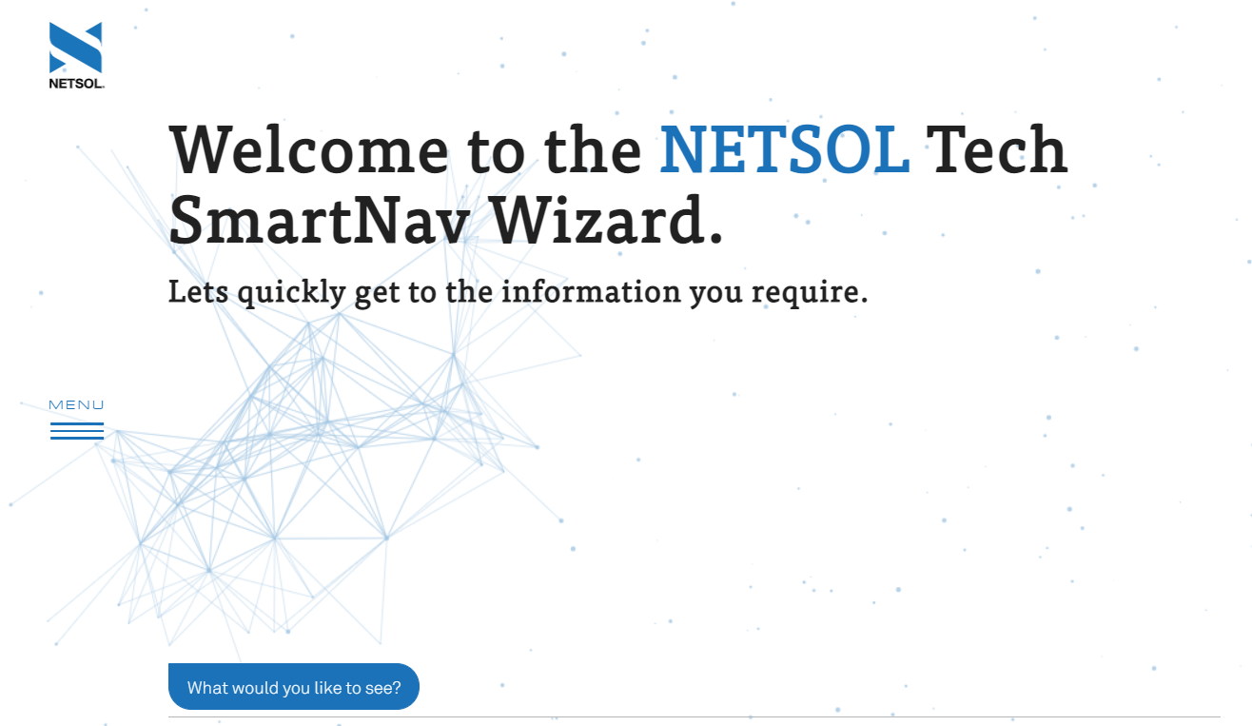

This is the navbar

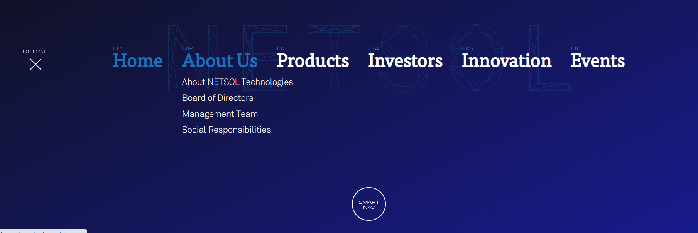

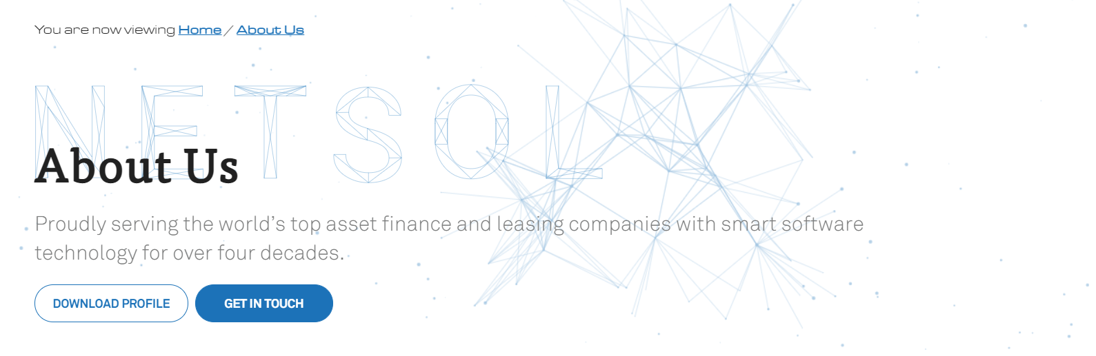

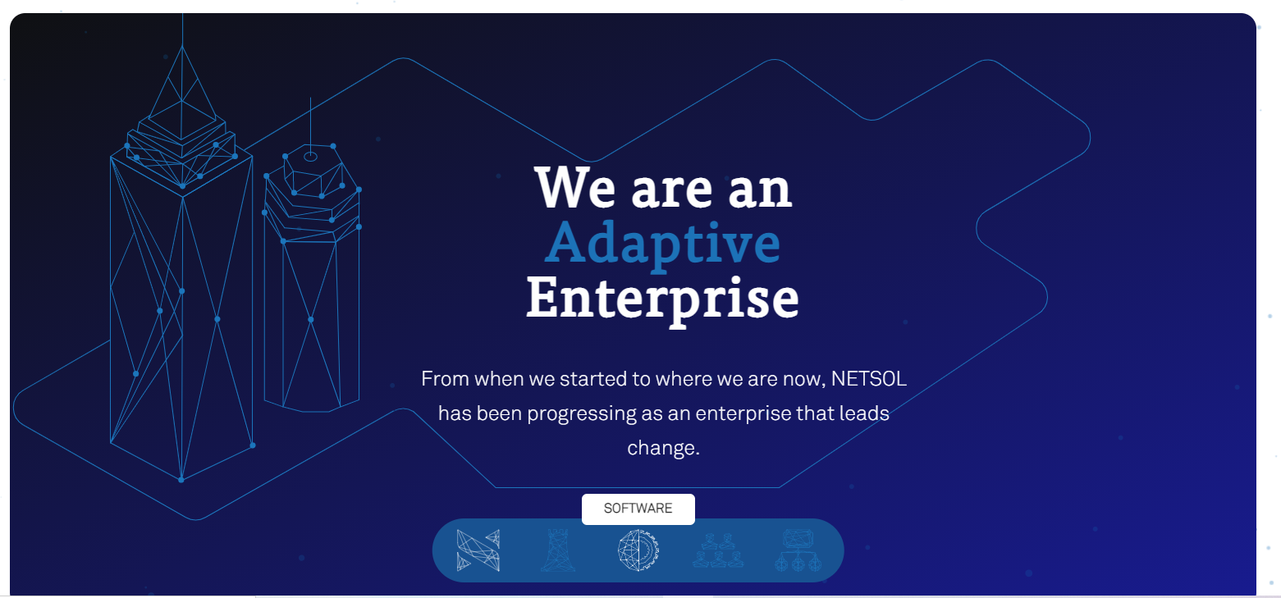

**Kalsoft:**

**Services:** Microsoft dynamics 365, Application development, Cognitive technologies.

**Offices:** UAE, Karachi, USA, Canada, Oman, KSA

**Techlogix:**

Since 1996

**Services:** Software product engineering, Digital transformation, application services, cloud transformation etc.

**Offices:** US, China, and Pakistan

**Zepto:**

## Headquartered: London

## Services: UX/UI design, development and software engineering, infrastructure and devops, big data, cyber security consulting services.

## Offices: Islamabad, Lahore, Faisalabad, Karachi

## GoodCore Software:

## Since 2005

## Headquartered: Croydon, UK

**Services:** Mobile App development, web app development, Desktop app development etc.

**Office:** Karachi

## [VENTUREDIVE PVT. LTD.](https://www.venturedive.com/?utm_source=themanifest.com&utm_medium=referral&utm_campaign=directory)

## Since 2012

**Services**: UX/UI design, IT strategy consulting, and cloud consulting & SI services

## Platforms: Salesforce, Amazon Web Services

## Office: Karachi